GAME DESIGN DOCUMENT (GDD) - TraffiCode

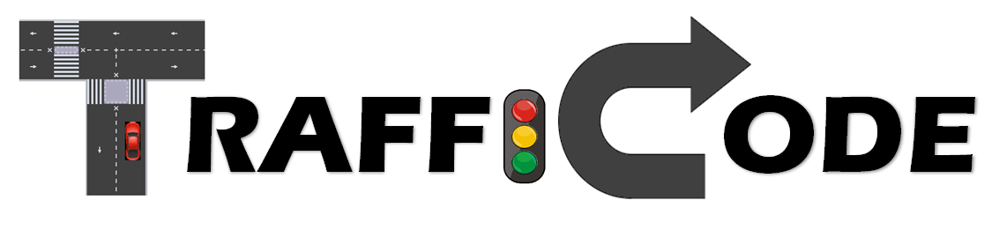

Genre:

Driving challenges (with regards to traffic codes)

Game Elements:

* Complete various driving missions with increasing traffic and road complexity.
* Drive as safely as possible to avoid losing points or getting caught by the police for major violations.
* Mind the buttons on the dashboard (lights, wipers, blinkers, air-conditioning) to receive bonus points, avoid loss of points and access additional features.

Players:

Single player vs. computer-driven vehicles and pedestrians

# TECHNICAL SPECS

Technical Form:

2D graphics (flat)

View:

Top-down

Platform:

PC

Language:

Python (primarily using Pygame library)

# GAME PLAY

The game will begin with a brief intro explaining your (the players') situation and motives. You only recently got your drivers license and you will be spending the day driving around on various errands with your young, impressionable brother and sister.   
You must follow the traffic code and avoid violations – A. because it's the law, B. because there is an insurance app on your mobile tracking how you drive and C… your siblings will DEFINITELY tell on you to your parents!

After the intro, you will begin level 1, with the very first mission being relatively easy in terms of traffic and road conditions. You would have to drive your car – your PARENTS' precious car – using the WASD keyboard keys. Said car would imitate real-world cars in terms of gradual velocity from 0 to max, braking to slow down, slower reverse gear and limited rotational capacity.

You will be able to see the relevant instructions for each level on your ever-present companion, your mobile phone, built into the dashboard.

* If you managed to drive perfectly the entire level and finish on time (before reaching the end of the countdown for the mission) – congrats, you would achieve perfect score and move on to the next level.
* If you managed to drive perfectly without any violations but didn't finish on time – that's not too bad, think of it as extra practice. Your insurance score will not be hit but you will have to restart the level and try to be just as good, only faster.

What happens if you were able to finish the level on time, but your driving was sub-optimal and involved commiting traffic violations?

* If you committed only minor violations (ignoring lane borders, driving over the sidewalk, speeding, running a stop sign, etc.) – meaning, some recklessness but no actual accidents – you will lose some points off your insurance score.   
  Besides the shame of possibly not finishing the game with a perfect score, it also means that your parents would have to pay a higer rate to keep you insured.   
  If the rate gets high enough before the end of the day, they might decide not to pay altogether, leaving you [gasp of horror] without wheels.
* If you committed major traffic violations, such as hitting another vehicle or, heavens forbid, a pedestrian - a police car would be sent out to chase you.
  + If the police catches you - you would be sent to "TraffiCode Refreshment Course", for a madatory review of some very basic, universal traffic laws.

After that annoying waste of a minute, you would have to restart the entire game, going back to level 1, but also back to a perfect score.

* + If they don't – you will advance to the next level, but your score would take a huge hit. In addition to any further violations you probably had to commit to get away. In this game, crime doesn't pay.

If at a certain point in time your score is low enough, the insurance company will contact your parents about paying a higher rate for your high-risk driving style, and they might cut you off for the rest of the day.   
In that case – it's game over, you would have to restart the entire game to prove to them that you can do better.

After finishing the top level, the game would end, and your score would be added to the insurance company's hi-scores board (if deemed worthy), which would make your parents VERY proud.

There are also several "easter eggs" hidden in the game, making it even more fun.

First, during your errands/missions, you will also happen to meet several interesting characters, like my friends Alla, Ari, Amit, Shaked & Maor, and others.

Also, the driver's dashboard, a command center of sorts, provides several additional buttons (blinkers, wipers, A/C, lights, etc.) that might come in handy and would absolutely increase your score if you use them right.

# Key Features

* Objectives
  + Each mission would have a clear, relatable objective that would motivate the player to complete it.
  + The overall objective of the game is, of course, to teach drivers (young and experienced) to pay more attention to following real-world traffic codes.

## Constraining Measures

## The player would have to navigate the car through semi-random traffic, avoid hitting other cars and pedestrians, and follow basic traffic codes.

## The player would also have to be fast enough to complete the mission within the countdown.

## If the player violated major traffic codes in order to complete the mission, they would have to outrun the police car chasing them but suffer major loss of points, or restart the entire quest back from level 1.

## Strategy

## Under the constraints and mission parameters, the player would have to employ creative thinking and sometimes sheer patience to complete the mission.

## Drawing the Players in

## The user interface would be engaging and cartoony, eye-catching but not overly serious and not necessarily an accurate representation of the real world (because real-world driving is usually a lot less fun…).

# DESIGN DEFINITIONS

Game Design Definitions

1. How the player wins:

* Player finished each and every level before the countdown.
* Player did not commit enough violations to make the score drop below the allowed bar during any of the levels.
* Player was not caught by the police in the current game.

1. How the player reaches the hi-scores board:

* Player finished the game with a score higher than the lowest recorded score.

1. How the player loses:

* Player committed a major violation and was caught by the police.
* Player committed a major violation and was not caught by the police but his score dropped below the allowed bar during the current / next level.
* Player committed enough minor violations that his score dropped below the allowed bar during the current / next level.

1. How the player completes a level:

Player reached finish line before the countdown…

* 1. Without any violations.
  2. With some minor violations but not enough to drop the score below the allowed bar.
  3. With a major violation but without getting caught by the police and without commiting further violations that dropped the score below the allowed bar.

1. How the player restarts a level:

* Player did not reach the finish line before the countdown.

1. How the player restarts the game:
   1. Player committed a major violation and got caught by the police.
   2. Player's score dropped below the allowed bar.
2. How the player gets hidden bonus points:
   1. If the lights are ON and the level background is dark.
   2. If the wipers are ON and the level background is rainy.
   3. If the air conditioning is ON and the level background is sunny.

# Game Flowchart

High-Level Game Flow

This is a high-level view of what the game logic should look like, from start to finish.

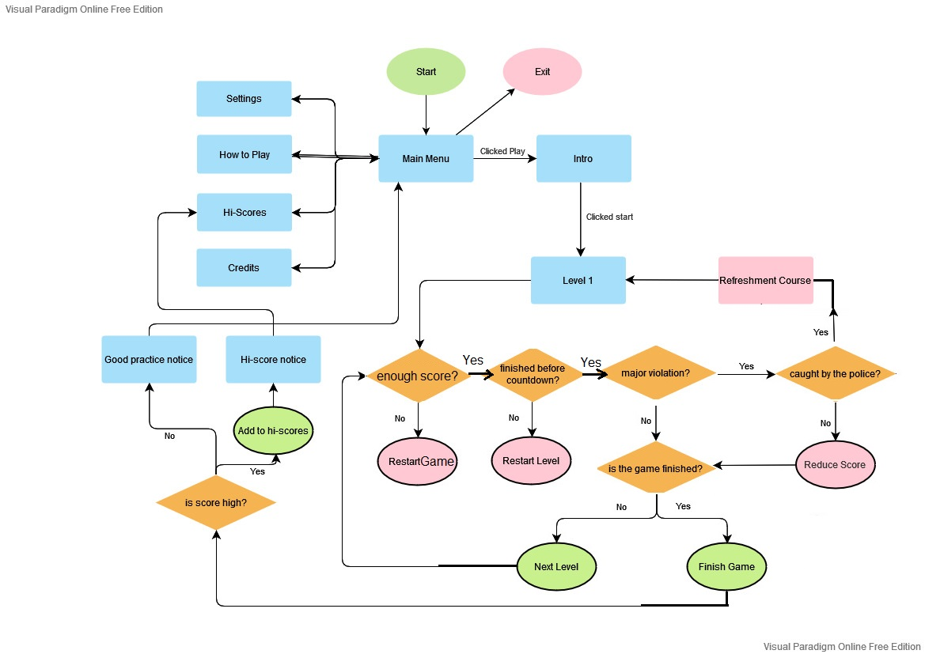

Level Initialization Flow

This shows the initializations that should happen at the start of each level.

# 

In-Level Logic Flow

This shows the functions and checks that should run within each level, from start to finish.

# 

# Player Definitions:

Our player is a young new driver (male or female) driving his/her younger brother and sister around for a day of errands.

The player has to get to the finish line in every level, before the countdown, while maintaining a minimum score – forcing him/her to at least try and drive responsibly.

The player has a few elements to consider while playing:

* The Score – perfect at the beginning of the game (level 1), but it can either drop (with every violation the player commits during the level) or go up (using the dashboard buttons to gain bonus points).   
  If the score drops enough, it's game over (like a health bar).
* The Dashboard – like in an actual car, it's basically the control panel for the player, only very simplified.   
  It will not include a steering wheel, but will show the speed of the vehicle. Other buttons, like Blinkers, Wipers, Lights, AC, Music and Main Menu – will be present and clickable.
* The Mobile – part of the dashboard, shows info for the current level and sometimes messages / calls.

# User Interface (UI) Design

The Game Play (mockup for representation only, NOT FINAL!)

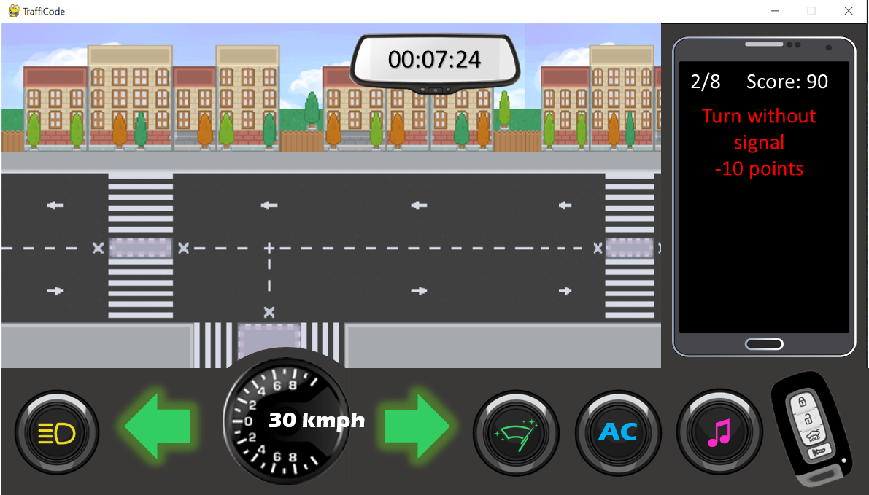

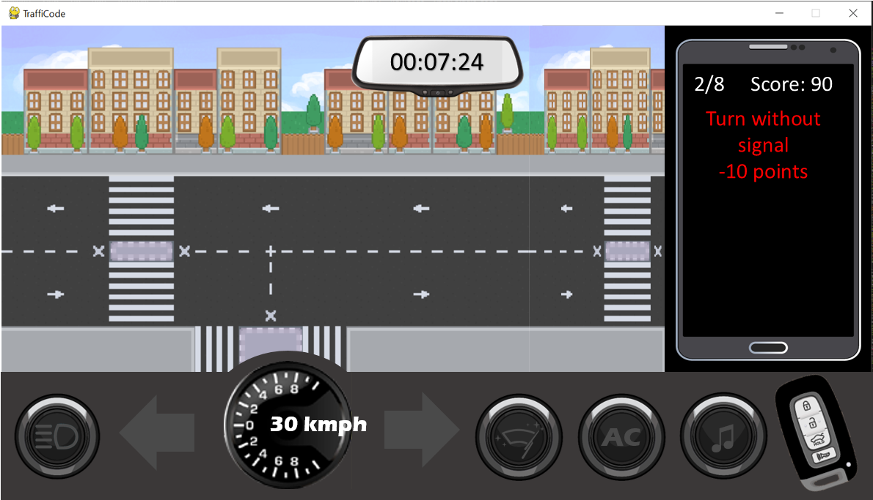

The first picture shows the buttons in ON mode, the second in OFF mode.

* Dashboard Elements

|  |  |  |
| --- | --- | --- |
| *Element* | *Purpose* | *Control* |
| Rear View Mirror | Show how much time is left for this level's mission (Countdown). | Non-clickable, display only. Will update automatically with every change. |
| Mobile | Show the current level. |
| Show the player's current Score. |
| Show the latest traffic violation the player performed in this level. |
| Show instructions for this level. |
| *Show messages and calls. |
| Speedometer | Show the player's velocity. |
| Blinkers | Signal before making a turn with the player's vehicle. | Click using the left mouse button. |
| Lights, Wipers, AC | Earn bonus points based on the scene's background. |
| Music | Switch between soundtracks. |
| Key Fob | Pause the level.  Navigate to main menu of the game. |

*If there will be enough time to add.

* The Scene – new scene for each level of the game.   
  The background (sky) will also change between levels (sunny/rainy/dark).
* The Player's car – controlled by the WASD keys on the keyboard:
  + W = accelerate
  + A = turn left
  + D = turn right
  + S = brake / reverse

The Main Menu (mockup for representation only, NOT FINAL!)

* Menu options navigation – point and click using left mouse button.

|  |  |  |
| --- | --- | --- |
| *Element* | *Purpose* | *Control* |
| Game Logo | - | Non-clickable, display only. |
| Settings |  | Click using the left mouse button. |
| How to Play | Show the game's instructions. |
| Hi-Scores | Show the highest scores earned in the game. |
| Credits | Show the makers' credits. |

The TraffiCode Refreshment Course (mockup for representation only, NOT FINAL!)

* Menu options navigation – point and click using left mouse button.

Intro

Outro

# Level Definitions:

Intro

TraffiCode Refreshment Course

Outro

Level 1 – Exit the house

Level 2